Table of Contents

Rolsa Technologies Designs 1

Logo: 1

Colour Scheme: 1

Application components/pages 2

Sidebar: 2

User Dashboard: 3

Login: 3

Register: 4

Booking Step 1: 4

Booking Step 2: 5

Database Structure / Data Dictionary 7

Booking Flowchart 8

**Design documentation**

**ROLSA technologies**

Table of Contents

Rolsa Technologies Designs 2

Logo: 2

**Task 1 Proposal**

The proposal for a digital solution that will provide customers with relevant information that is up to date. This information will include green energy products that are currently on the market and information on how to reduce the carbon footprint. It will also allow for customers to schedule installations and consultation right from the application. Another feature it will also allow is for customers to calculate their carbon footprint.

# **Rolsa Technologies Designs**

## Logo:

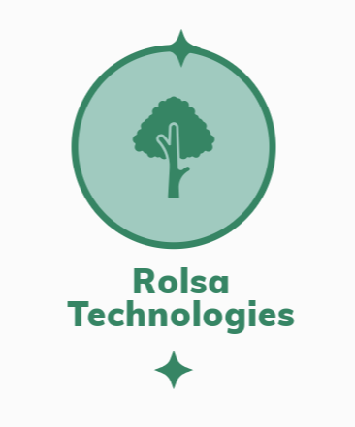

I have created a logo for the Rolsa Technologies which I did using Adobe Express Logo Maker. The logo has a tree to signify their green ambition and efforts through the logo. I personally like the logo as it is modern and has a bold statement about being green as represented by the tree in the middle of the logo.

## Colour Scheme:

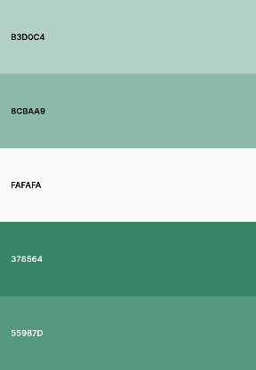

The following is the colour pallet for the designs. I have chosen these colours to match the logo design, and it will make a great user experience because the company is about green energy, so we need to make sure that the colours reflect that. I have looked into how the colours will integrate with the design and I think they will blend in nicely.

# **Application components/pages**

These are the pages and components for the application of Rosla technologies that have been designed in Figma.

## **Sidebar:**

## **Homepage:**

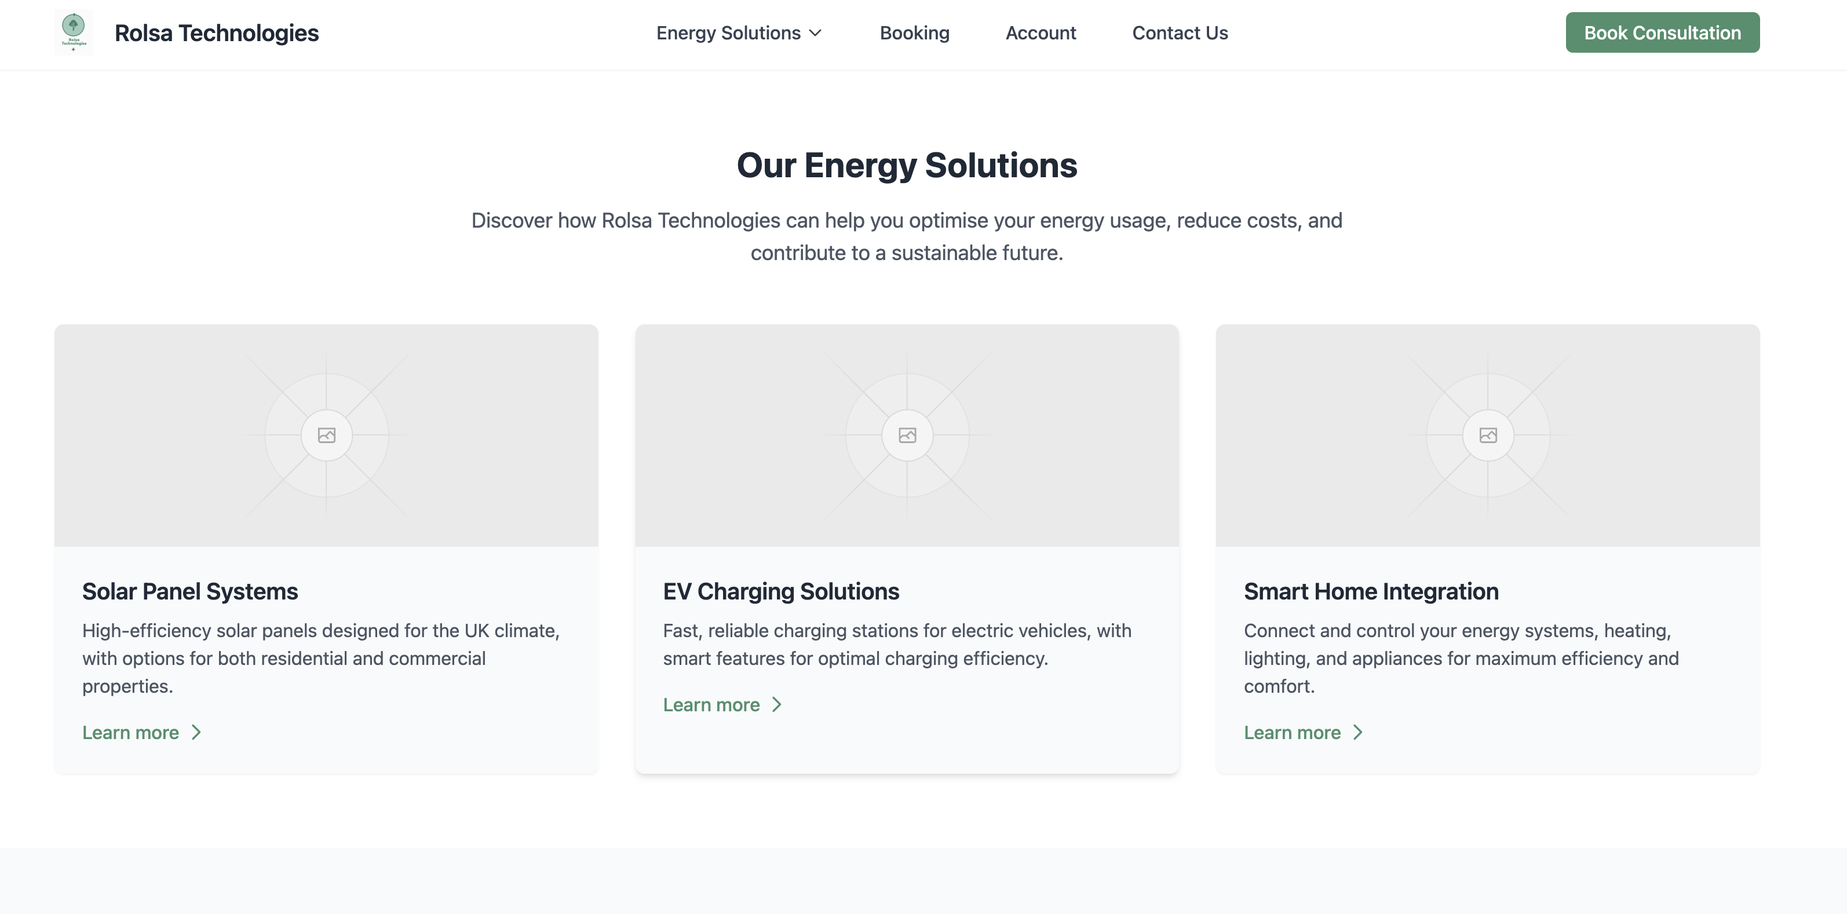

## **User Dashboard:**

## **Login:**

## **Register:**

## **Booking Step 1:**

## **Booking Step 2:**

**Booking Step 3:**  
**Booking Confirmed:**

**Admin View Bookings:**

# **Database Structure / Data Dictionary**

The database is structured in a way that it doesn’t have many tables, but we can have the information we need in there. Users table is the table that will store all the customers login information. We will use bcrypt for password hashing to make sure it’s secure. There is a role value that will determine what the user is and what permissions they should get.

The booking table will help the staff and admins know what booking they have at what type and the status of the booking to see if it has been complete by the team.

Energy usage table is the final table of the database and tells the customer their energy that they are using and it is linked to their user_id.

# **Booking Flowchart**

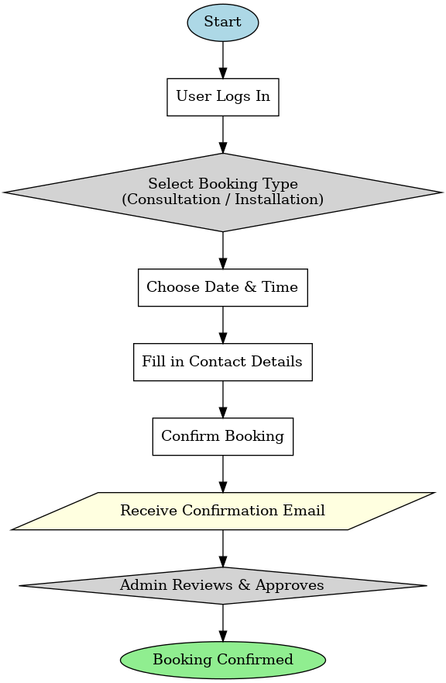

|  |  |  |  |
| --- | --- | --- | --- |
| **Date of Test** | **Component to be Tested** | **Type of Test to be Carried Out** | **Prerequisites and Dependencies** |
| 18 April 2024 | Navigation Bar | Black box testing -> Functional testing: Integration testing | No data inputs needed at this stage, tester will go through the navbar and test if all the correct pages are loaded. EX: clicking on Dashboard should load the Dashboard page. |
| 18 April 2024 | Dashboard | White box testing, Black box testing -> Functional testing: Integration testing, Unit testing | No Data needed. Testing if all the buttons are functional, verifying that the energy tracking graphs display correct values, and ensuring dashboard elements load properly. |
| 18 April 2024 | Booking System | White box testing, Black box testing -> Functional testing: Integration testing, Unit testing | No Data needed. Testing if users can schedule, edit, and cancel appointments, ensuring correct interactions between frontend and backend. |
| 20 April 2024 | Booking System (Database) | Backend -> Database Testing | Test if any errors are shown while executing queries. Test data needed: UserID, booking details (date, time, type of service), and confirmation status. |
| 18 April 2024 | Login Page | White box testing, Black box testing -> Functional testing: Integration testing, Unit testing | No Data needed. Testing if login works correctly, handling incorrect passwords, and verifying JWT authentication. |
| 20 April 2024 | Login System | Backend -> Database Testing | Test data needed: Valid username and password, invalid credentials to check system robustness. |
| 18 April 2024 | Sign Up Page | White box testing, Black box testing -> Functional testing: Integration testing, Unit testing | No Data needed. Testing if users can register, ensuring email verification works, and validating password strength. |
| 20 April 2024 | Sign Up System | Backend -> Database Testing | Test data needed: Name, email, username, password, and validation for duplicate accounts. |
| 18 April 2024 | Energy Tracker Page | White box testing, Black box testing -> Functional testing: Integration testing, Unit testing | Test if energy usage data is fetched correctly from the backend, verifying AI-based energy-saving recommendations. |
| 20 April 2024 | Energy Data System | Backend -> Database Testing | Test data needed: User energy consumption logs, correct calculation of weekly/monthly usage trends. |
| 18 April 2024 | Accessibility Features | Black box testing -> Non-Functional testing: Accessibility testing | Test if screen readers work correctly, ensure high-contrast mode is supported, validate WCAG 2.1 compliance. |
| 18 April 2024 | Performance Testing | Load testing, Stress testing | Simulate 1000 concurrent users accessing the dashboard, API response times should remain <200ms. |
| 20 April 2024 | Security Testing | Penetration testing, SQL Injection testing | Test system vulnerability to SQL injection, brute-force login attacks, and verify encryption of sensitive user data. |
| 18 April 2024 | Multi-Device Compatibility | Black box testing -> Non-Functional testing: Compatibility testing | OS needed: iOS, macOS, Windows, Android. Browsers: Chrome, Edge, Firefox, Opera, or Safari. |

The application will feature the following features:

|  |  |
| --- | --- |
| **Requirement** | **Description** |
| Account registration | This allows customers to register and account and manage their data such as consultations and installation. |
| Accessibility features | These features will be added to help make it accessible to a wider range of users making it user friendly for all. |
| Energy Tracker | This feature will track the energy use of home and give suggestions and tips on how to improve the usage and give valuable insight into there usage. |
| Account Sign In | This is a feature that will let existing users of the system authenticate. |

The application will feature the basic features that an application that offers these services normally have as a standard. These features will attract potential users as people would like to view their usage to keep the costs down and if it’s made easy to view, they will attract more customers.

In term of the business, it will help speed up operations as they won’t need to go and read the data to get a usage reading it will all be digital so they can free up the staff to do some more complicated tasks.

In terms of data handling, the application will use a cloud database which is managed by a third party who are dedicated into keeping the database data safe which will be cheaper and more reliable than a local database. The platform will also use an AI personalisation feature that will identify trends in the energy usage and give you dedicated feedback.

We also understand the importance of a secure platform which is why we are taking these measures to make sure it stays this way.

|  |  |
| --- | --- |
| **Measure** | **Description** |
| Password Policy | Make sure that passwords are at the correct standard of at least 8 characters and one special character. |
| Password Hashing | Make sure that the password is hashed so that people can not understand it if they get access into the database. |
| Password Timeouts | If the user enters the password incorrectly a number of times the account will either be locked until more authentications can be provided or a selected amount of time for example 12 hours. |
| Access Control | Make sure only whitelisted ips have access to the database to prevent anyone from connecting to it. |

To comply with GDPR laws, we will offer a delete information button which will delete the user’s information within 30 days of them requesting.

**Tech Stack**

|  |  |
| --- | --- |
| **Component** | **Technology** |
| Front End | EJS (embedded JavaScript) |
| Backend | Node.js with Express.js |
| Database | Local MySQL database |
| Authentication | JSON Web Token |

The reason for using EJS as a front end is that we can easily render JavaScript into HTML with this language and allows us to use EJS tags to embed variables onto a html page so we can make a login page easily. It’s also good for conditions so for example we need to only display a component for only admins we can do so easily with EJS.

The reason for using Node.js with Express.js for the backend is that they are good tools for using EJS with as they allow us to pass through variables to the front end to render them and they allow us to render the pages so we can do login and dashboard easily.

The reason for using a local MySQL database is that the stored storage is local on the server which allows only us to control the data which is better because then no third party has access to the data which is more secure.

I have decided for authentication to use JSON web token which is a standard when choosing this type of tech stack as it offers great security and is used by businesses all over the world.

**Database Structure / Data Dictionary**

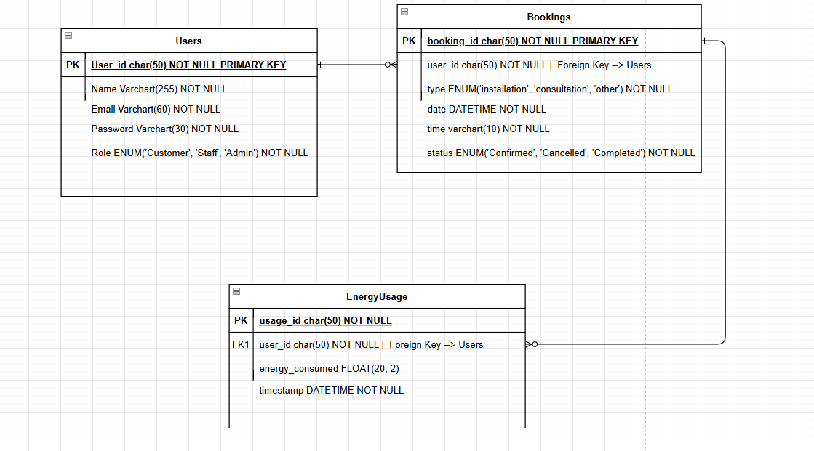

The database is structured in a way that it doesn’t have many tables, but we can have the information we need in there. Users table is the table that will store all the customers login information. We will use bcrypt for password hashing to make sure it’s secure. There is a role value that will determine what the user is and what permissions they should get.

The booking table will help the staff and admins know what booking they have at what type and the status of the booking to see if it has been complete by the team.

Energy usage table is the final table of the database and tells the customer their energy that they are using and it is linked to their user_id.

**API Structure**

|  |  |  |
| --- | --- | --- |
| Endpoint | Method | Description |
| /api/auth/register | POST | This will send a post request that will add the user to the database and then they will be registered. |
| /api/auth/login | POST | This post request will send the request to the database and make sure that the username and password are correct then it will authenticate the user. |
| /api/bookings | GET | This will retrieve the authenticated users bookings. |
| /api/bookings/:id | DELETE | Cancel a booking |
| /api/energy-usage | GET | Get the authenticated users energy usage. |
| /api/admin/report | GET | This will get the data for a admin report. |
| /api/book | POST | This will send the booking to the database and create a booking. |
| /api/bookings/:id | PUT | Update a booking |

This API structure will give the front end everything it needs to access the data to the backend. It has authenticated routes so they are protected so only the authenticated user can access them which is good API security. Admins will be able to delete, add and edit new bookings and the customer will be able to edit their own booking as well.

Proposal  
  
  
  
The proposal for a digital solution that will provide customers with relevant information that is up to date. This information will include green energy products that are currently on the market and information on how to reduce the carbon footprint. It will also allow for customers to schedule installations and consultation right from the application. Another feature it will also allow is for customers to calculate their carbon footprint.

**Says**

* "I need more information about green energy before making a purchase."
* "Can I see a breakdown of my energy consumption so I can optimise usage?"
* "Is there a feature where I can schedule a consultation for solar panel installation?"
* "I want a system that provides personalised recommendations based on my energy consumption habits."
* "How do I track my appointments and installations?"
* "I need an easy way to cancel or reschedule my bookings."

**Thinks**

* "I wish I could see all the green energy options available before committing."
* "It would be much easier if I could schedule and manage my appointments online."
* "I need to know if my current energy usage is inefficient and how to improve it."
* "I want my experience to be personalised; recommendations based on my energy habits would be useful."
* "If I invest in solar panels or an EV charger, I need to be sure I'm making the right choice."
* "I want my data to be secure, especially when entering financial or personal information."

**Does**

* Visits the website but struggles to find all relevant information.
* Tries to book a consultation but finds the process confusing.
* Looks for recommendations but does not find personalised suggestions.
* Attempts to track energy consumption but finds the insights too generic.
* Wants to cancel an appointment but is unsure how.

**Feels**

* Overwhelmed by the amount of information available on green energy.
* Frustrated when the system lacks personalisation.
* Annoyed if the booking system is difficult to use.
* Uncertain about making a big financial investment in green technology.
* Reassured when the platform provides clear guidance on energy efficiency and cost savings.
* Satisfied when the system is user-friendly, allowing easy scheduling and tracking of installations.

This empathy map helps in designing a **user-friendly, informative, and efficient** digital solution for **Rolsa Technologies** customers, ensuring that their needs, frustrations, and desires are addressed effectively.

## **User Stories for Rolsa Technologies**

|  |  |  |  |
| --- | --- | --- | --- |
| **As a...** | **I want...** | **So that...** | **Acceptance Criteria** |
| First-time customer | To visit the website and find clear information about green energy solutions | I can compare available options and understand how Rolsa Technologies can help me | The homepage should have a clear navigation bar, and an informative section about services, including solar panels, EV chargers, and energy management |
| Homeowner | To track my energy consumption and get recommendations | I can reduce my electricity costs and make informed energy decisions | The system should display detailed energy usage analytics and personalised energy-saving tips |
| Business owner | To schedule an installation and manage my bookings | I can ensure my office has sustainable energy solutions without disrupting operations | The booking system should allow businesses to schedule, modify, and track solar panel installations and EV charger setups |
| Returning customer | To log into my account and see my past consultations and purchases | I can manage my previous bookings and get loyalty rewards for future installations | The website should provide a user dashboard where customers can view and track their history, manage appointments, and see discounts for repeat purchases |
| Environmentally conscious user | To receive personalised sustainability reports | I can track my carbon footprint and see how I’m contributing to a greener future | The dashboard should provide insights into energy efficiency and CO₂ savings based on user data |
| Customer with accessibility needs | A website that is easy to navigate with accessibility features | I can comfortably use the platform regardless of my abilities | The system should comply with WCAG 2.1 accessibility standards, offering screen reader support, high contrast mode, and keyboard navigation |

## **Functional Requirements**

### **Homepage**

* The system should display a homepage that consists of a **navigation bar, main section, and footer**.
* The main section should have a **carousel of images** linking to key pages (e.g., energy solutions, consultation booking, and account management).
* No data inputs required.
* Clicking on navigation links should take users to the appropriate page.

#### **Navigation Bar should include:**

* Home
* Energy Solutions
* Book Consultation
* Track Usage
* Account

### **Energy Solutions Page**

* The system should display detailed information about available energy solutions (solar panels, EV charging, and smart home management).
* Users should be able to compare different solutions and access customer reviews.
* No data inputs required.

### **Booking System**

* Users should be able to **book a consultation or installation appointment**.
* The system should allow users to select:
  + **Service Type** (Consultation or Installation)
  + **Date and Time**
  + **Personal Information** (Full Name, Email, Phone Number)
* Once submitted, the booking should be stored in the database, and users should receive a confirmation message.
* Users should be able to cancel or modify their bookings from the **account dashboard**.

### **Energy Tracker Dashboard**

* Users should be able to view their **real-time and historical energy usage**.
* The system should provide **AI-powered recommendations** based on energy consumption patterns.
* Users should be able to download a **PDF report** of their energy consumption for a selected time frame.

### **User Account System**

* Users should be able to **create an account, log in, and manage their bookings and energy tracking**.
* The account page should display:
  + **Upcoming bookings** (with options to cancel or reschedule)
  + **Past energy consumption reports**
  + **Account settings (password change, contact details update)**
* Logout functionality should be available.

#### **User Input Requirements for Account Creation:**

* Full Name
* Email
* Username
* Password
* Confirm Password

#### **User Input Requirements for Login:**

* Username
* Password

## **Non-Functional Requirements**

### **Security**

* The system should ensure **secure data handling**:
  + All input data must be validated.
  + Secure cookies should be used for authentication.
  + Passwords should be hashed using **SHA256 encryption**.

### **Maintainability**

* The system should be **easy to maintain and update**.
* Clean coding practices should be followed, including:
  + Proper **naming conventions** for variables and functions.
  + Use of **standard API formats**.
  + Well-structured **database design** for scalability.

### **Performance**

* **Page load speed** should be within **2-6 seconds**.
* **Latency** should be below **100ms** for API responses.
* **Efficient API calls** should be implemented to prevent system overload.

### **Usability & Accessibility**

* The system should be **user-friendly and intuitive**.
* It should comply with **Web Content Accessibility Guidelines (WCAG 2.1)**, ensuring:
  + High contrast mode for visually impaired users.
  + Screen reader compatibility.
  + Keyboard navigation support.

This document ensures that **Rolsa Technologies’ digital platform** meets **functional, security, performance, and accessibility requirements**, providing a **seamless and informative** user experience.

## **Decomposition of Rolsa Technologies Website**

### **Energy Solutions**

* Navigation bar
* Detailed breakdown of green energy options
* Customer case studies
* Pricing plans
* FAQs
* Footer

### **Booking System**

* Navigation bar
* Book a consultation
* Book an installation
* Select date and time
* Input personal details
* Booking confirmation
* Footer

### **My Account**

* Navigation bar
* Sign up/Sign in
* Reset password
* View energy usage reports
* Cancel or reschedule bookings
* View past services and rewards
* Logout
* Footer

## **Key Performance Indicators (KPIs)**

|  |  |
| --- | --- |
| **KPI** | **Target** |
| **Website Load Time** | Pages should load within **2-6 seconds** |
| **API Response Time** | All API calls should respond within **100ms** |
| **Booking Completion Rate** | At least **90% of users** should successfully complete bookings without errors |
| **User Engagement** | Users should spend an average of **3-5 minutes** on the platform per session |
| **Conversion Rate** | At least **20% of visitors** should complete a booking or consultation request |
| **Customer Satisfaction** | Achieve a satisfaction rating of **4.5/5 or higher** based on user feedback |
| **Security Compliance** | 100% of user passwords and sensitive data must be encrypted using SHA256 |
| **Accessibility Compliance** | The website should adhere to **WCAG 2.1** accessibility standards |
| **System Uptime** | Maintain **99.9% uptime** for uninterrupted service |
| **Bug Resolution Time** | Fix reported bugs within **48 hours** of detection |

## **Justification**

### **How the Recommended Solution Meets the Client’s Needs**

#### **Inclusion-Driven Solution**

* The website will be designed to support all users, including those with accessibility needs.
* It will use **WCAG 2.1-compliant design** to ensure usability for everyone.

#### **Efficient Booking System**

* A **robust booking system** will allow customers to schedule consultations and installations seamlessly.
* The client can **track sales and appointments**, leading to better strategic decisions.

#### **Comprehensive Energy Information**

* A **dedicated energy solutions section** will provide users with detailed insights into green energy options.
* Customers will have access to **personalised AI-driven recommendations** based on their usage patterns.

#### **Personalised User Experience**

* The **account system** will allow users to track their bookings, receive loyalty rewards, and view energy reports.
* Secure logins and **data encryption** will ensure privacy and security.

### **Risk Mitigation**

|  |  |
| --- | --- |
| Risk | Mitigation Strategy |
| **Informational Inaccuracy** | Regular updates and content management system for easy modifications. |
| **Data Loss in Booking System** | Automated backups and a thoroughly tested database. |
| **Security Breaches** | Implementation of **SHA256 password encryption** and **MFA for authentication**. |
| **Compliance Issues** | Ensuring GDPR compliance for data protection and WCAG 2.1 for accessibility. |

This justification ensures that the **Rolsa Technologies Digital Solution** is **efficient, scalable, and customer-centric**, making it a **strategic investment for the client**.

## **Appendix 1: Hardware and Software**

### **1. Smart Meters & IoT Sensors**

* Collect real-time energy usage data from solar panels and EV chargers.
* Allow customers to monitor their energy consumption efficiently.
* Improve decision-making with automated data collection and reporting.

### **2. High-Performance Cloud Servers**

* Host the Rolsa Technologies platform, ensuring **99.9% uptime** and fast response times.
* Enable secure storage of customer data, bookings, and transaction histories.
* Support scalability as the company grows.

### **3. AI-Powered Analytics Engine**

* Processes energy usage data to provide **personalised recommendations**.
* Detects inefficiencies and suggests **optimisation strategies**.
* Uses machine learning to improve forecasts on energy savings.

### **4. Secure Payment Gateways**

* Ensures safe online transactions for customers booking consultations and installations.
* Uses **SSL encryption** and multi-layer security protocols to prevent fraud.
* Supports multiple payment methods, including credit cards, Apple Pay, and Google Pay.

### **5. Web-Based & Mobile-Optimised Platform**

* Designed using **React.js (frontend) and Node.js (backend)** to ensure high performance.
* Mobile-responsive, allowing customers to access features from any device.
* Integrates with Progressive Web App (PWA) technology for a seamless experience.

### **6. Blockchain for Data Security & Transparency**

* Implements **blockchain-based smart contracts** for secure booking verification.
* Reduces risk of data breaches with **tamper-proof encryption**.
* Ensures transaction logs remain transparent and immutable.

### **7. Renewable Energy Forecasting Software**

* Uses AI models to predict solar energy production based on weather conditions.
* Provides customers with insights into the best time to use stored energy.
* Helps maximise efficiency for users relying on solar energy solutions.

Appendix 2

Software Development for Leisure, Travel & Tourism: Tech Trends for 2023

(youteam.io)

7 Top Tech Trends Emerging in the Tourism Industry in 2024 | She Owns It

List of 9 Legal Requirements for Websites and Tips